Guideline for Suppliers
September 2016
Content
Getting Ready for E-commerce 2
1. Dimensions 2
2. Weight 2
3. Prices 3
Receiving quotations 3
1. When a buyer requests a quotation for your items 3
2. When you click on the Request for quotation, you can make your quote: 4
2. Fill in your best offer and click ‘Send Quote’. The buyer will receive your quotation and will be able to order the item. 5
After receiving an order on SIM 6
1. E-mail notification with “You’ve Received an Order!” 6
2. E-mail notification with “You have a new sales order” 6
3. View order: 6
4. SIM Team issues a Purchase Order to you and the status will be changed to ‘Ready to Ship’ 7
5. Press ‘Ready to Ship’ when goods are ready to be picked up 8
6. The following screen appears 8
7. Now you are able to download the sticker (packaging label) per order line and attach it to the package: 9
8. The instructed carrier have been informed and will pick up the package 9
9. You are able to Track the package via the Tracking Number on the packaging label on the website of the carrier 9
10. The package is delivered and your order overview will show: 10
11. You will receive an e-mail confirmation of the delivery 10
Track all status in your dashboard 11

Getting Ready for E-commerce
In order to make it possible for buyers to directly order your products via the Spares in Motion platform basic information per item is required.
- Price
- Lead time
- Size and weight
This information can be filled in during the RFQ process or upfront. Especially the information to calculate shipping cost, size and weight will add value for the buyer to do upfront. This can be done via ‘Edit Part’:
(We are working on a upload feature to do this via Excel. If you want to add this information to a list of products please contact support@sparesinmotion.com. )
Manual process to fill in shipping data. Go to your products via your dashboard. After you have clicked on my parts and supplies you will find your products with an edit button.
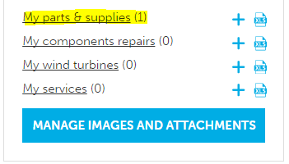

1. Dimensions
Enter the packaging dimensions per standard minimum quantity (e.g. per piece) in centimeters for Length, width and height
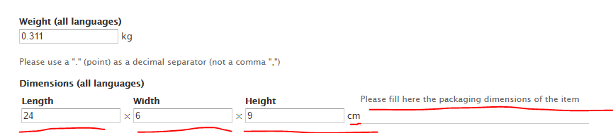

2. Weight
Enter the weight per item in KG. If the items is less than 1 kg, use a point (“.”) as a decimal separator:
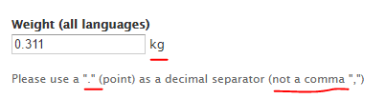

3. Prices
Enter a price per item to enable buyers to order and pay for the item directly on the platform. You can also choose not to fill in a price and then the buyer first needs to ask you as a supplier for a quote and price.
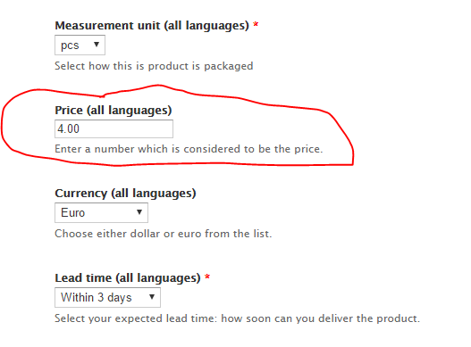

Receiving quotations

When a buyer requests a quotation for your items
You still will receive an notification email and you can find the RFQ in your message center.
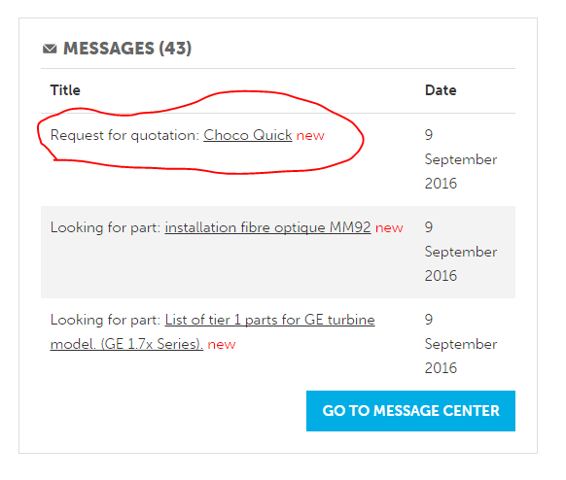

2. When you click on the Request for quotation, you can make your quote:
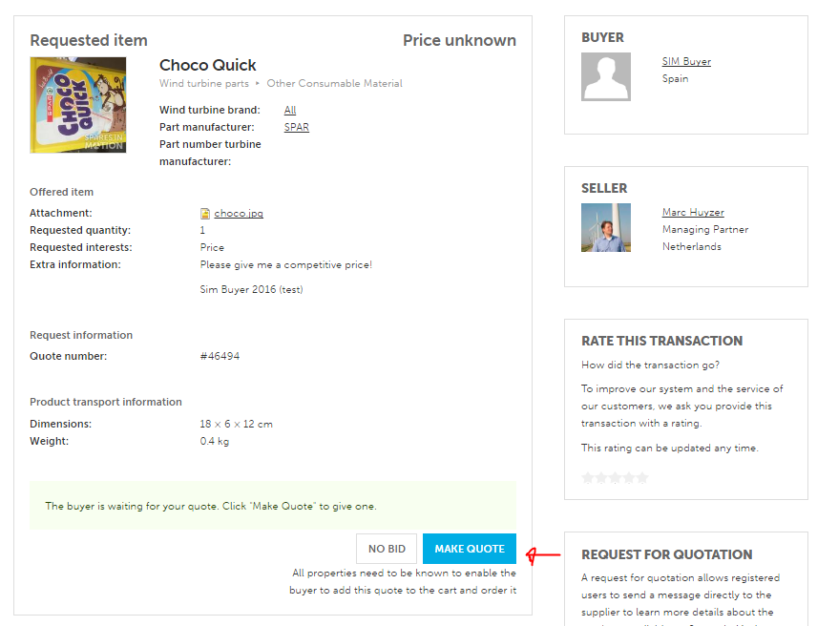

Fill in your best offer and click ‘Send Quote’. The buyer will receive your quotation and will be able to order the item.

Please fill in all fields to offer the buyer to order online.
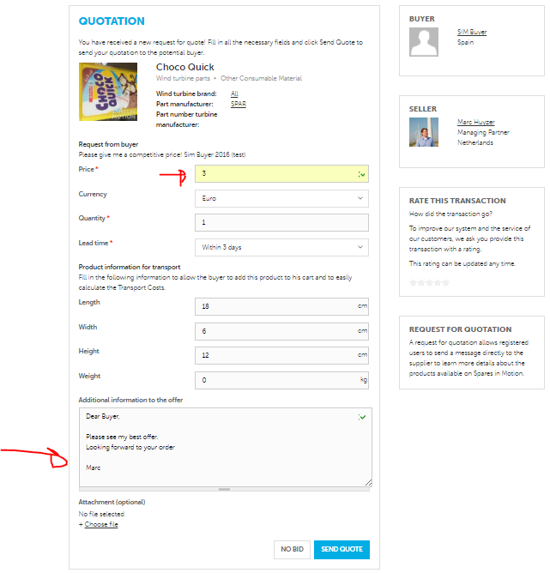

After receiving an order on SIM

1. E-mail notification with “You’ve Received an Order!”
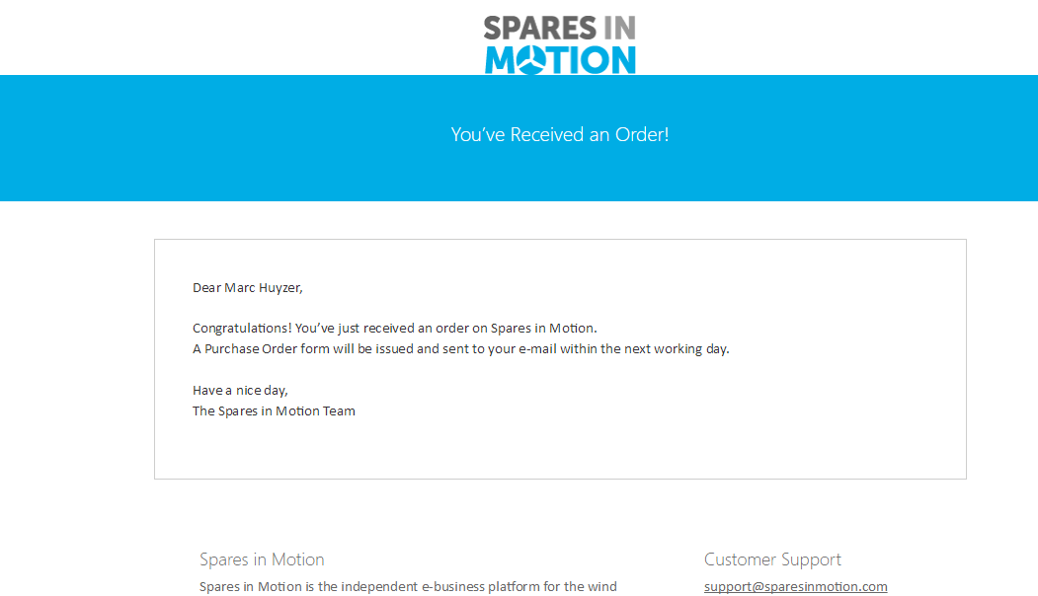

2. E-mail notification with “You have a new sales order”
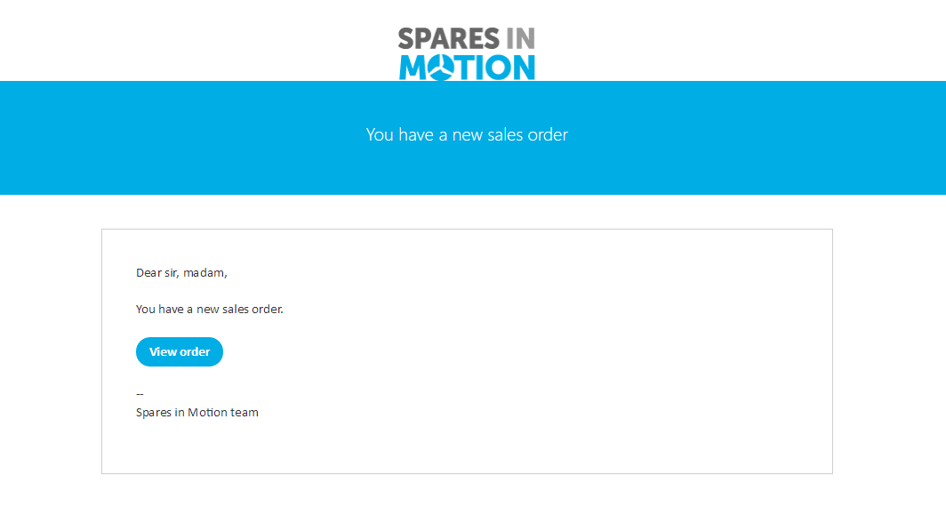

3. View order:

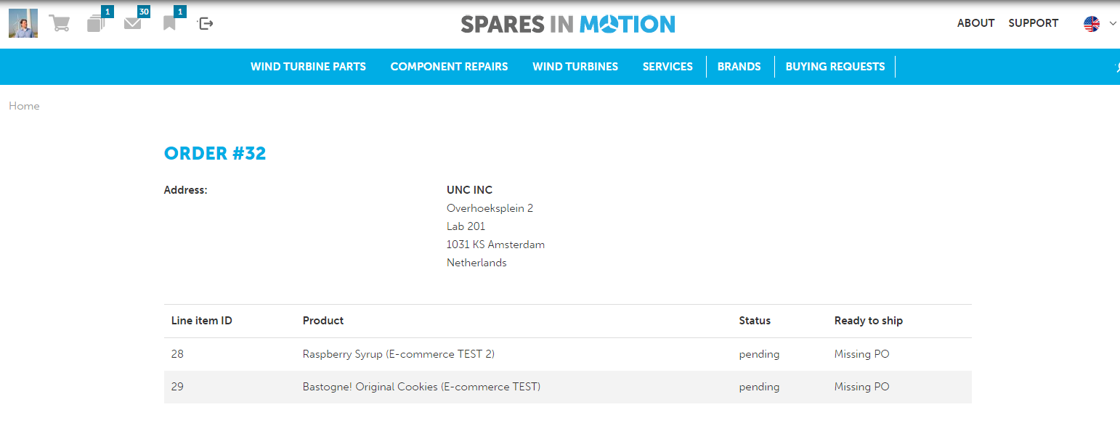

4. SIM Team issues a Purchase Order to you and the status will be changed to ‘Ready to Ship’

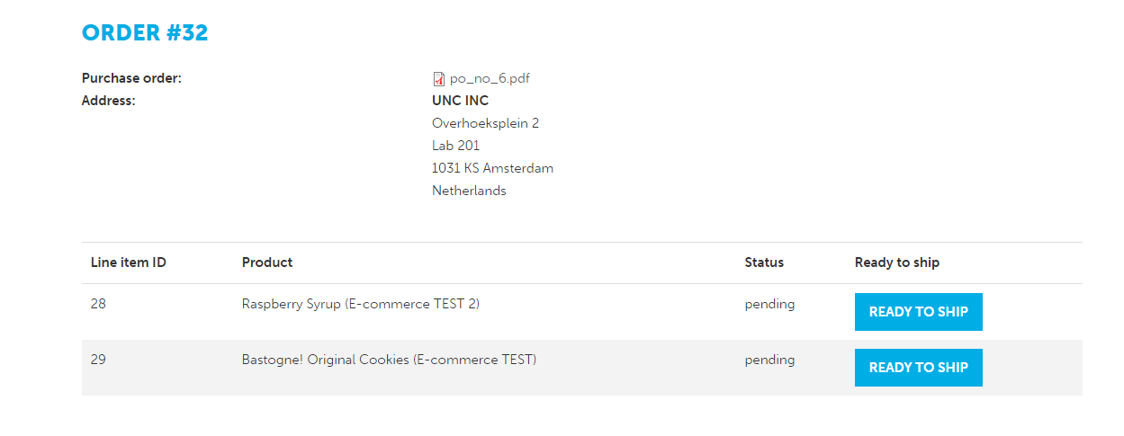

5. Press ‘Ready to Ship’ when goods are ready to be picked up
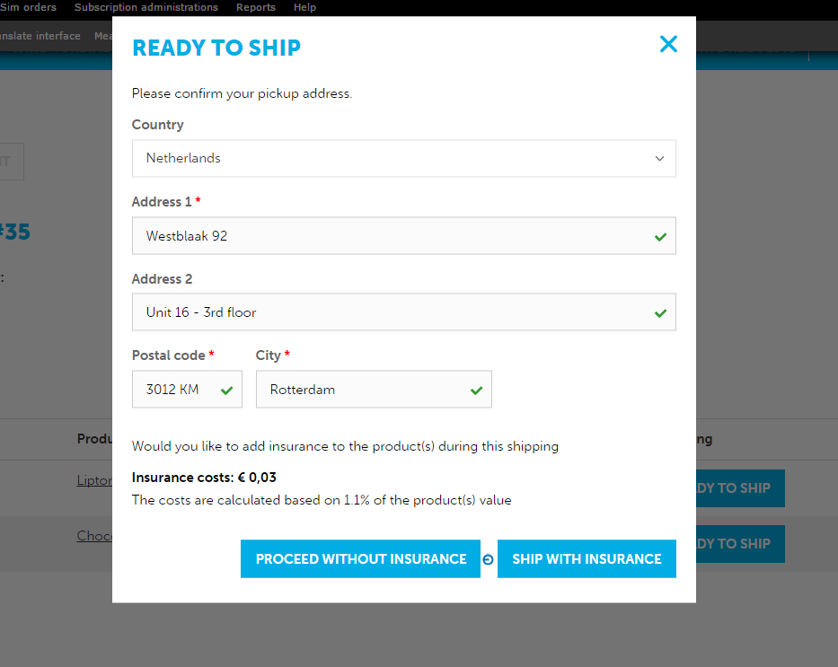
You are able to add transport insurance for 1,1% of the value of the products.

6. The following screen appears
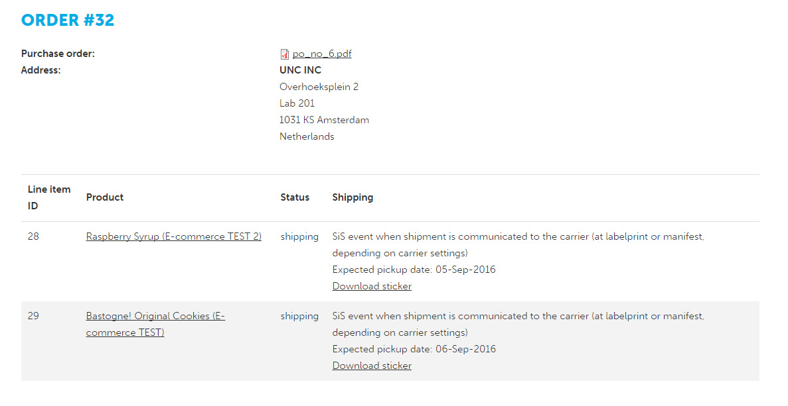
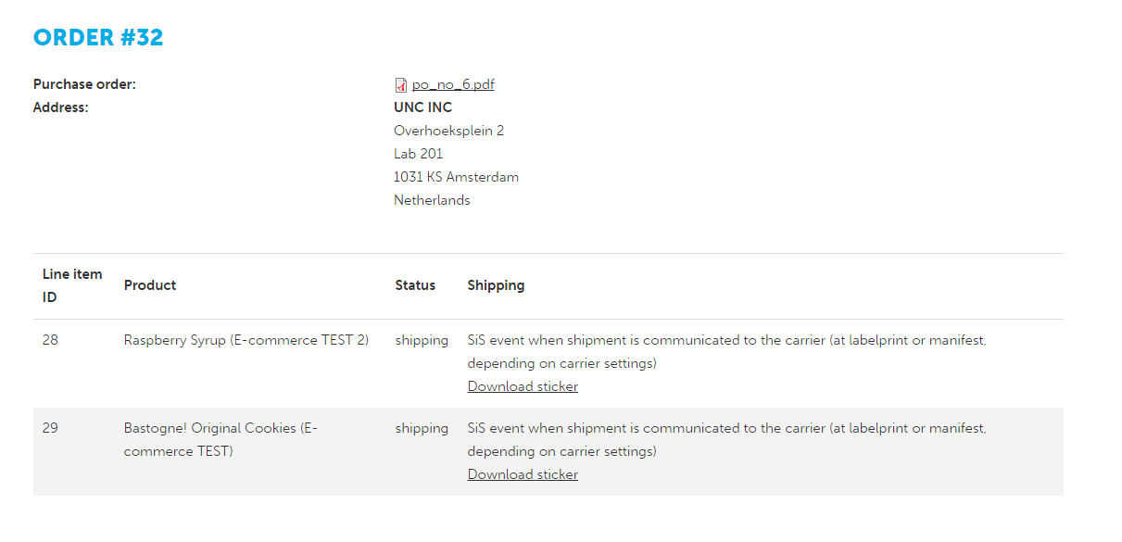

7. Now you are able to download the sticker (packaging label) per order line and attach it to the package:
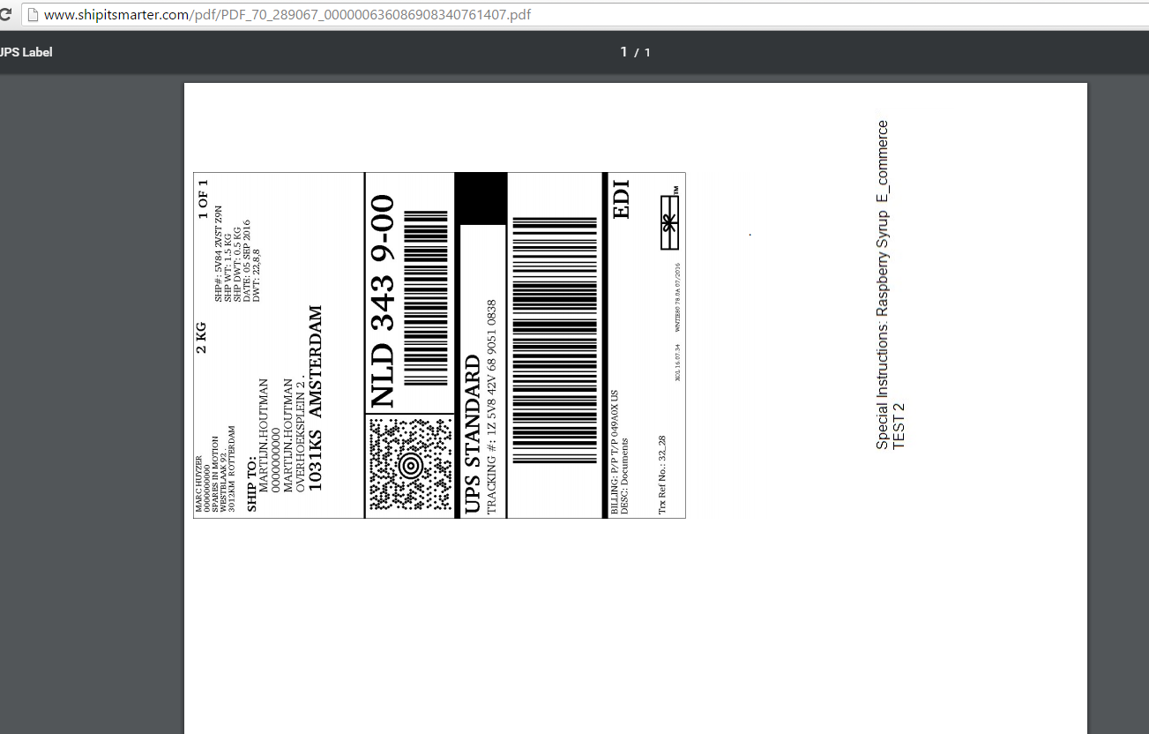

8. The instructed carrier have been informed and will pick up the package
Package will be picked up and the status in your dashboard will change.

9. You are able to Track the package via the Tracking Number on the packaging label on the website of the carrier

10. The package is delivered and your order overview will show:

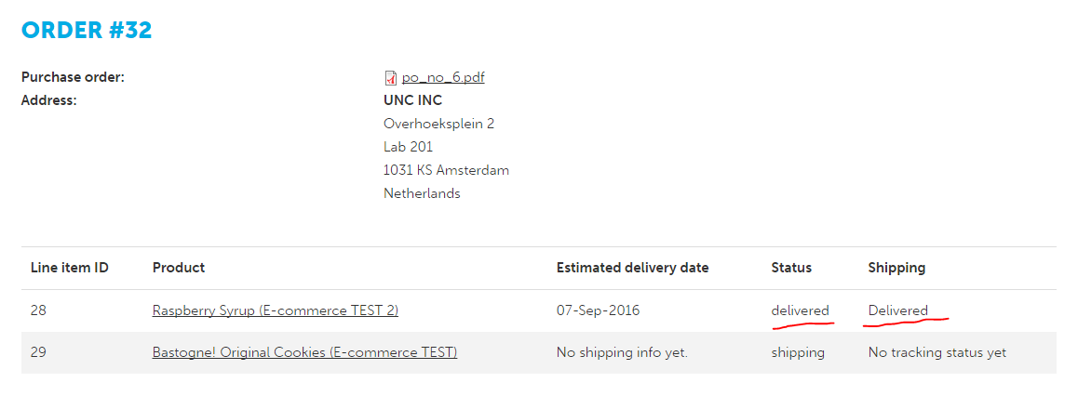

11. You will receive an e-mail confirmation of the delivery
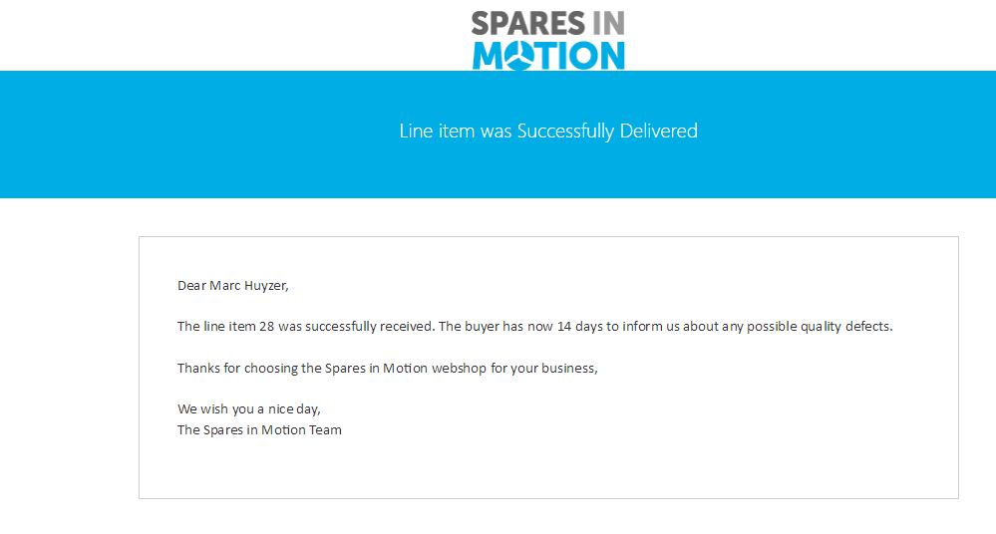

Track all status in your dashboard
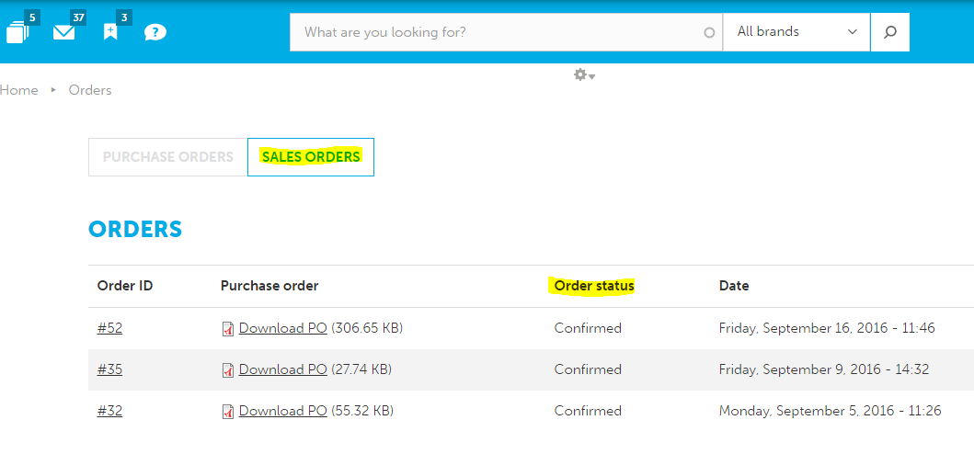
- In sales orders you can track your orders including order status.
- Here you can also download the PO for your products:
